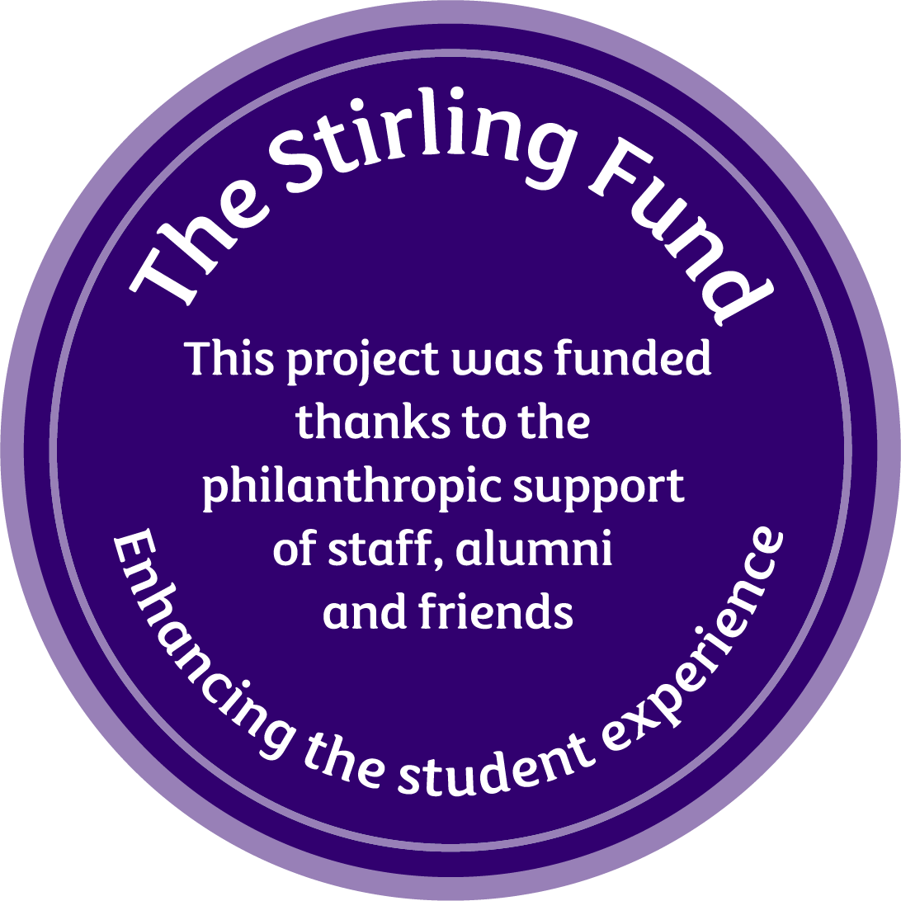

**The *Stirling Fund***

**Small Grants Funding Application (2024-25)**

Please ensure that **ALL** of the fields below are completed before submitting your application. It is strongly advised that before you begin your application you carefully read the *Stirling Fund* Guidelines and refer to examples of successful applications. It is recommended that your application is proofread before submitting.

**Data protection**  
By completing the form below you are consenting to us processing your personal information for these purposes; if you are not content with this, please do not proceed. Your data will be stored securely and will only be accessible to relevant staff in the Development and Alumni Relations Department and members of the selection panel. You can read our Privacy Statement at <https://www.stir.ac.uk/alumni/about-us/dataprotectionstatement/>

|  |  |
| --- | --- |
| **PROJECT TITLE** |  |
| Amount being applied for £ |  |
| Your name |  |
| Faculty, Department, Club or Society |  |
| Your position in above |  |
| Phone |  |
| Email |  |
| If you are a **student** of the University (year, subject) |  |
| If you are a **member of staff** your faculty/department/  directorate |  |
| Has this project received support from the Stirling Fund or Vice-Chancellor’s Fund in the past? **Yes No**  ***If your answer is 'Yes', please provide the project name, year of application, and brief overview of the project*** |  |

Please give a full description of the project, outlining key objectives and highlighting how the project would enhance the student experience at the University of Stirling (max 500 words).

|  |
| --- |
|  |

How many students are you expecting to benefit from this project?

|  |
| --- |
|  |

Is your project targeting a particular group or category of students (international students, LGBT+, minorities, etc..)? If yes, please describe how. (max 100 words)

|  |
| --- |
|  |

Please provide a budget with estimated costs, showing how you would use a grant from the Stirling Fund. Please also include if other funding has been secured or if you have applied for additional funding. Should you be successful, you will be asked to provide a detailed report on expenditure following the completion of the project.

|  |  |  |  |  |  |  |  |  |  |  |  |  |  |  |  |  |  |  |
| --- | --- | --- | --- | --- | --- | --- | --- | --- | --- | --- | --- | --- | --- | --- | --- | --- | --- | --- |
| |  |  |  | | --- | --- | --- | |  |  |  | |  |  |  | |  |  |  | |  |  |  | |  |  |  | | **Total** |  |  |   **The Stirling Fund Budget** |

**CONDITIONS OF THE AWARD**

These grants are intended to enhance and enrich the student experience, and these are stories that we need to share with our donors, staff, friends, and supporters of the University of Stirling. A condition of accepting this grant is that Project Managers must provide written feedback and photos regarding the success of the project for future marketing purposes. This should be sent to [alumni@stir.ac.uk](mailto:alumni@stir.ac.uk). The project must be promoted through the use of the Stirling Fund icons, which will be provided to successful projects. The Development and Alumni Relations Team will request a progress report at regular intervals.

**REFERENCES**

**Ensure that your references align with your project's goals.** If your project involves resources from a different department, such as estates or sports, remember to obtain a reference from that department. This will enable them to understand your project's requirements and provide appropriate assistance.

Furthermore, please note that your reference must be a member of staff or a previous employer – not a member of your committee or a friend. If you are a student applicant, please include a reference from a member of staff from the Students’ Union.

• Academics should include a reference from a School Manager or Dean.

• Student projects that are academically related should provide a reference from the appropriate faculty (i.e. a psychology-related project would require an academic reference from that department as a reference).

|  |  |
| --- | --- |
| Reference One | Reference Two |
| Name: | Name : |
| Position: | Position : |
| Address: | Address: |
| Phone : | Phone : |
| Email : | Email : |

**USEFUL CONTACTS**

**STIRLING STUDENTS’ UNION**

Union President ([president.union@stir.ac.uk](mailto:president.union@stir.ac.uk))

VP Communities ([communities.union@stir.ac.uk](mailto:communities.union@stir.ac.uk))

VP Education ([education.union@stir.ac.uk](mailto:education.union@stir.ac.uk))

Sports President ([sports.union@stir.ac.uk](mailto:sports.union@stir.ac.uk))

**ESTATES AND CAMPUS SERVICES**

[ECSAdmin@stir.ac.uk](mailto:ECSAdmin@stir.ac.uk)

**Please see the** [***Stirling Fund’s***](https://www.stir.ac.uk/about/our-people/alumni/support-stirling/the-stirling-fund/apply-to-the-stirling-fund/) **webpage for closing date**

**Please ensure you rename your finalised application document to the title of your project.**

Once ready, please email your completed application(s) to [alumni@stir.ac.uk](mailto:alumni@stir.ac.uk).

**THANK YOU FOR YOUR APPLICATION**