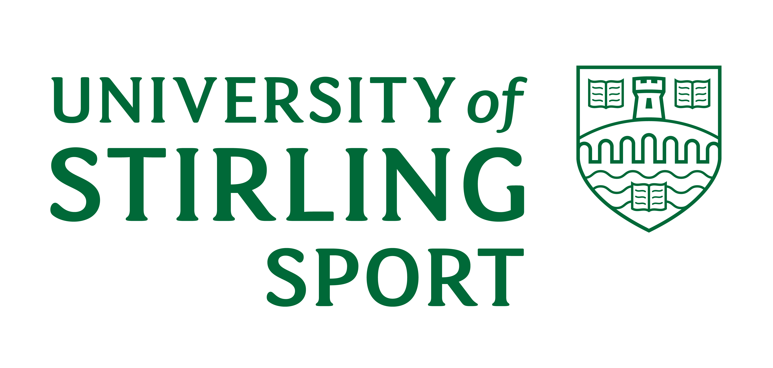

SPORTS DEVELOPMENT SERVICE

INTERNATIONAL SPORTS SCHOLARSHIP PROGRAMME

APPLICATION FORM

PERSONAL DETAILS
Surname

Other Names

Title
Permanent address

Telephone No.

E-mail Address

Correspondence address (if different from above)

Country of birth

Nationality

Date of birth

Age on 30th September next | Years Months

ACADEMIC CAREER

Education

School attended:

Examinations passed (show grade and year of passing for Standard Grade, Higher, GCSE, ‘A’ level or equivalent)

Examinations to be taken (if none, write ‘none’)

Entry to University

Proposed entry date:

Have you already applied through UCAS for admission to a University? YES/NO

If YES, please quote

- UCAS Serial number __________________________________________

      - Course(s) applied for __________________________________________

      - Universities applied to __________________________________________

__________________________________________

If NO, please indicate your intentions regarding formal application and subjects of academic interest.
SPORT

CHOSEN SPORT:

SPORTING ACHIEVEMENTS

Please list results achieved over the past several years as evidence of having achieved the normal minimum standard for a scholarship award that is national junior standard, e.g. selection for Scottish Boys or Girls, or placing in a national championship e.g. semi-finals Scottish Boys or Girls.

REFERENCES
Please give the name, address and status of two referees who can supply information on your sporting achievements and potential.

Name: Name:

Address: Address:

Status: Status:

Applicant’s Signature:

Date:

When completed, this form should be returned to:

David Bond
Head of Performance Sport
Sports Development Service
University of Stirling
Stirling, FK9 4LA
Tel: 01786 466910
david.bond@stir.ac.uk

