Faculty of Arts and Humanities Postgraduate Conference PLAY AND IMAGINATION
Friday 23 May 2025, University of Stirling

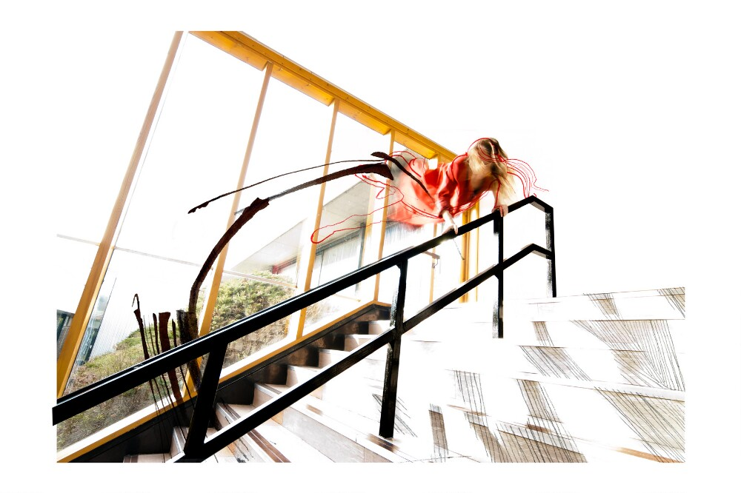
Image: Hartley, B. (2010s) Pathfoot 1 [Photomontage]. University of Stirling Art Collection.
9:00am-9:50am - Registration and Coffee
Pathfoot D3

9:50am-10am - Opening Remarks
Pathfoot Lecture Theatre
Professor Christine Ferguson, Associate Co-dean for Graduate Studies, Faculty of Arts and Humanities, University of Stirling

10am-11am - Keynote Talk: Children’s Games: A Reflection on the Work of Francis Alÿs
Pathfoot Lecture Theatre
Professor Tim Ingold, University of Aberdeen

11am-12:30pm - Knowing through Taking Part
Pathfoot D1
Chair: Dr Elizabeth Robson, University of Stirling

- Ritual as Performance, Research as Play: Participatory Ethnography and Dramatic Occult Rituals - Rebeka Erdélyiová, Newcastle University
- “Talk to me about the LEGO!” A qualitative exploration of autistic students’ experiences with LEGO-Based Therapy - Kyleigh Melville, University of Edinburgh
- Heritage, Planning and Place: New Futures for Participatory, Creative Place-Making - Ieuan Rees, University of Stirling
- Imagination as Methodological Praxis - Georgia Haynes, University of Edinburgh

11am-12:30pm - Play as Pause
Pathfoot Lecture Theatre
Chair: Dr Dale Leorke, University of Stirling

- “The readers are pretty numerous”: Libraries and Social Identity in Nineteenth-century Orkney - Jacqueline Imrie, University of Stirling
- "Climbing over the ruins" Discussions on the past, present and future of (un)ruined heritage sites as communal spaces - Tomas Gerich, University of Stirling
- Sea battles, spangles and swimming lessons: playful performances at amateur aquatic entertainments in late Victorian Glasgow - Lucy Janes, University of Stirling

12:30pm-1:30pm - Lunch
Pathfoot D3

1:30pm-3pm - Interacting with Environments
Pathfoot Lecture Theatre
Chair: Lilja Bernheim, University of Stirling

- Using Minecraft for children’s education on climate change - Chloë Corcoran, University of Stirling
- How to Touch Nature: A comparative analysis of contemporary art practice influenced by Chinese Taoist culture and Western Eco-feminism - Yimou Huang, University of Dundee
- Probing beneath the surface: play and imagination in object-driven research with a curious maritime collection - Alina Botezatu, University of Stirling
- Ecotheatre Home - Kelsey D. Grubbs, University of Edinburgh

1:30pm-3pm - Technology as Catalyst
Pathfoot D1
Chair: Dr Vanicka Arora, University of Stirling

- Learning Gaelic in the Singularity - Connor Eckersall, University of St Andrews
- Imagination on the Radio: Walter Benjamin and Thinking Playfully About Technology Education - Jodie Williamson, University of Dundee
- Cozy Games - Amy H. Ahn, University of St Andrews

3pm-3:15pm - Coffee
Pathfoot D3

3:15pm-4:15pm - Making Alternative Futures
Pathfoot Lecture Theatre
Chair: Dr Maria Vélez-Serna, University of Stirling

- Sweetening the Systems: Play as Power in Ge Yulu’s Performances - Jiahui Zhou, University of Edinburgh
- Playing with Multiple Fictions: Feminist Fictioning as Counter-Narrative and Worlding Strategy in a Misogynistic Society - Wenyi Pan, University of Edinburgh

- Hieronymus Bosch’s Imagination: Modern Science and Alternative Worlds - Nuo Cheng, University of Dundee

3:15pm-4:15pm - Engaging in Embodied Creativity
Pathfoot D1
Chair: Anu Shree Murali, University of Stirling

- How to Blow up a PowerPoint: the role of play and imagination in climate transformations - Amanda Douge, University of Glasgow
- Creative Writing for Well-Being: Using Playful Writing to Prevent Burnout - Carolyn Grisold, University of Dundee

4:15pm-5:15pm - Keynote Talk and Performance: Towards a Concept of Interstitial Intelligence (A Play)
Pathfoot Lecture Theatre
Professor Steve Scott-Bottoms, University of Manchester

5:15pm-5:30pm - Closing Remarks
Pathfoot Lecture Theatre
Conference Committee, University of Stirling

