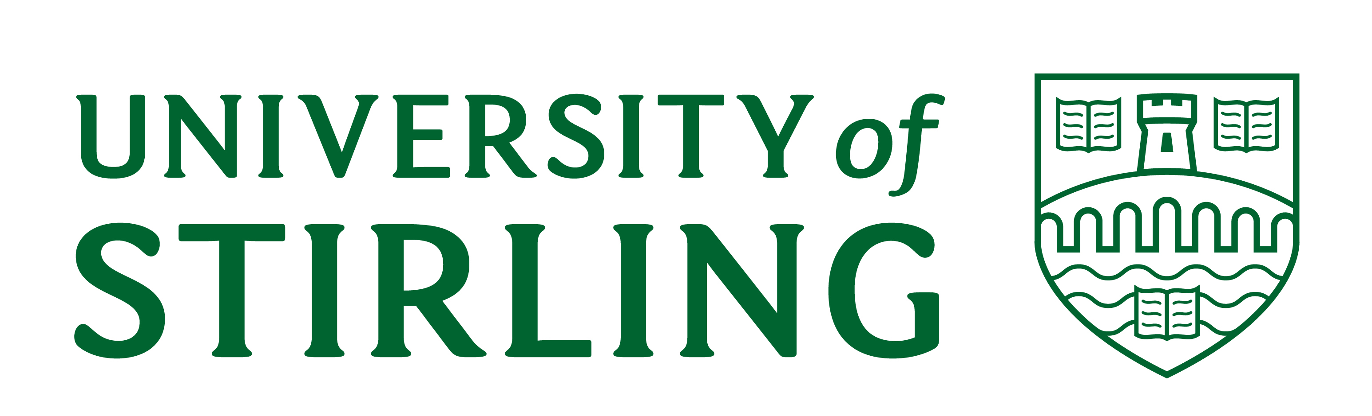

HR & OD DEPARTMENT

PERSONAL DETAILS/ACCEPTANCE FORM

Full Name
Address 1

Please complete the details below, which are required for payment purposes.
**NB: Existing employees are only required to sign the declaration.

Name and Address of Bank to which salary is to be paid |  | Sort Code
 |  | Account Number (8 digits)
Date of Birth | National Insurance Number
Nationality:
EMERGENCY CONTACT DETAILS
Name: Relationship:

Address:

Tel No 1: Tel No 2: Tel No 3:
Name of previous employer / Institution

Have you ever worked for another UK Higher Education Institution?  Yes  No  Name of HE Institution: | HESA Number (If you have worked for another UK HEI before, then you will have a HESA number. If this is known please supply HESA number below).
INCOME TAX
Please send your P45 Certificate to the HR & OD Department. If you do not have a P45, please complete and return the enclosed P46 form to ensure the correct tax code is applied.

RIGHT TO WORK
If your right to work documents have not already been seen by the Faculty / service area, please bring them along to the HR & OD department. Documentation check list can be found here (http://www.hr-services.stir.ac.uk/policies-procedures/index.php)

FIXED TERM CONTRACTS ONLY
I understand that this is a fixed term contract which is due to end on the date specified in my letter of appointment. I accept that there is a genuine rationale for the post being offered on a fixed term basis and that I have no expectation of an extension or renewal of the contract beyond this date.

QUALIFICATIONS AND CV’S
If not already supplied and has been requested as part of your offer of employment, please send copies of these documents to the HR & OD Department or email to hroperations@stir.ac.uk

STATEMENT OF ACCEPTANCE
I have noted the statement of Terms and Conditions of Service and I wish to accept the enclosed offer of appointment and agree to abide by the University's Charter and Statutes, Ordinances and the Rules and Regulations as set out in the University of Stirling Calendar.

Signed ..................................................................................... Date .....................................................


DATA PROTECTION ACT 1998

The University of Stirling requires to process and retain, in electronic form or otherwise, certain personal data relating to you, by virtue of your employment by the University. All personal data provided by you will be treated strictly in accordance with the terms of the Data Protection Act 1998. This means that confidentiality will be respected and that all appropriate security measures will be taken to prevent unauthorised disclosure. The data you provide (e.g. such data may include but is not limited to, name, designation and employment contact details) will only be used for official University purposes, including official University correspondence, responses to legitimate enquiries regarding University affairs, official publications relating to University affairs and on the official University world wide web pages and also for external organisations and web sites that promote the University’s research, researchers and their publications. For these purposes, and in accordance with the University’s notification to the Information Commissioner, personal data may also be transferred outwith the European Economic Area, to countries which may not have equivalent data protection laws.

Other than for the purposes described above, the University will not disclose your personal data to any third parties without your express consent, except where the University is required by law to do so, or where such disclosure is for the prevention or detection of crime, the apprehension or prosecution of offenders, or the assessment or collection of any tax or duty.

In the administration of your employment, the University also requires to process some data which current legislation refers to as “sensitive personal data” (i.e.. information relating to your racial or ethnic origin, physical or mental health or condition, marital status, trade union affiliation, commission or alleged commission of any offence, etc). Appropriate security measures will be in place to ensure that sensitive personal data are retained confidentially and are not retained any longer than is necessary.

At various times during your employment you may be asked to disclose personal data to University departments. Such requests remain subject to your individual rights under the Data Protection Act 1998 and you may if you wish withhold personal data from publication.

The University will retain your personal data only as long as necessary for its purposes as described. Please note, however, that even after termination of your employment, the University may still require to retain your personal data to satisfy its obligations to keep certain records for particular periods under applicable law.

The University strives to ensure that all personal data remain current and accurate. There are some areas, however, where the University relies upon employees to inform it of any changes; for example contact and next of kin details. We would therefore request that any changes to personal details be communicated to the HR & OD Department Ext.7136. For further information on this issue, please see http://www.hr-services.stir.ac.uk

I have read and understood the above data protection statement and give my consent to the processing of my personal and sensitive data as described:

Signed…………………………………………………. Date……………………………..

Print …………………………………………………...

If you also consent to your data being passed to those Trade Unions recognised by the University of Stirling [(as listed in the Data Protection Guide referred to below)] please tick the following box

For further information on the University of Stirling’s Data Protection Guide please see: http://www.guides.stir.ac.uk/dataprotectionguide.htm or contact the University Data Protection Officer at dataprotection@stir.ac.uk

EQUAL OPPORTUNITIES MONITORING FORM
The University of Stirling wishes to promote equal opportunities in all its employment practices. To do so information is asked of candidates and employees which will help us eliminate any practices which may be discriminatory. The information you provide will be handled in strictest confidence and will only be used for statistical monitoring purposes.
Complete this form and return to Human Resources (Room 4B1 Cottrell Building or hroperations@stir.ac.uk)

1. EMPLOYEE DETAILS
Full Name (known as) |  |  |  |  |  |  |  |  |  | Title
Employee Number |  |  |  |  |  |  |  |  |  | Faculty/Service
2. AGE
My date of birth is (dd/mm/yy)
3. GENDER
My gender identity is | ◻ Female ◻ Male  ◻ Other gender identity ◻ Prefer not to say |  |  |  |  |  |  |  |  |  | Is your gender identity the same as assigned at birth? |  |  |  |  | ◻ Yes  ◻ No  ◻ Prefer not to say
4. RELIGION
I would define my religion or belief as
◻ Buddhist  ◻ Christian - Protestant  ◻ Christian – Roman Catholic  ◻ Christian – Other _______________ |  |  |  |  |  |  | ◻ Sikh  ◻ Jewish  ◻ Muslim  ◻ Hindu |  |  |  | ◻ Another Religion __________________  ◻ No Religion or belief  ◻ Prefer not to say
5. NATIONALITY
My nationality is
6. ETHNICITY
I would describe my cultural and ethnic origin as
Asian, Asian Scottish or Asian British  ◻ Bangladeshi  ◻ Chinese  ◻ Indian  ◻ Pakistani  ◻ Other Asian Background |  |  |  |  | Black or Black British  ◻ African  ◻ Caribbean  ◻ Other Black background  Other  ◻ Other ethnic background  ◻ Prefer not to say |  |  |  | White  ◻ British  ◻ Scottish  ◻ Other British  ◻ Irish  ◻ Irish Traveller  ◻ Other White background |  |  |  |  |  | Mixed  ◻ White and Black African  ◻ White and Black Caribbean  ◻ White and Asian  ◻ Other Mixed background
7. DISABILITY
Do you consider yourself to be disabled |  |  |  |  |  |  |  | ◻ Yes ◻ No ◻ Prefer not to say
Please indicate what type of disability you have
◻ Blind or serious visual impairment  ◻ Cognitive Impairment  ◻ Deaf or serious hearing impairment |  |  |  |  |  | ◻ General Learning Disability  ◻ Long Standing Illness or Health Condition  ◻ Mental Health Condition |  |  |  |  |  | ◻ Physical Impairment or Mobility Issues  ◻ Specific Learning Disability  ◻ Other type of Disability  ◻ Prefer not to disclose type of disability
8. SEXUAL ORIENTATION
I would describe my sexual orientation as |  |  |  |  |  |  |  | ◻ Bisexual ◻ Gay man  ◻ Gay woman / Lesbian ◻ Heterosexual / Straight  ◻ Other ◻ Prefer not to say
9. CARING RESPONSIBILITY
Do you have caring responsibilities (i.e. are you the primary caregiver to a child or children, or other dependents including disabled, elderly or sick adults)? |  |  |  |  |  |  |  | ◻ Yes  ◻ No  ◻ Prefer not to say
HR ACTIONS
• SAP updated HR Office Signature: Date:

