Examiner’s Report for Degree of  Doctor of Letters (D.Litt.) | 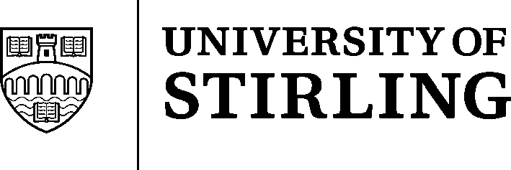

Candidate’s Name:

Examiner’s Name:

The regulations of the University of Stirling stipulate that the degree may be granted to a candidate who presents for examination a collection of published work, or a specially composed thesis based on such published work, which constitutes an original and substantial contribution of high distinction to scholarship and which establishes the candidate as an international authority in the particular field of study.

Recommendation:
that the degree of D.Litt. be granted
OR
that the degree be not granted

Signature of Examiner: | Date:

Report:
If necessary, please continue overleaf

Report (continued):

