Application for the Degree of  Doctor of Letters/Doctor of Science | 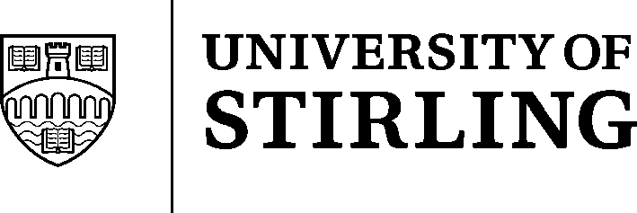

Potential applicants should refer to the regulations for degrees of Doctor of Letters (D.Litt.) and Doctor of Science (D.Sc.).

Extract from the regulations (please (x) whichever is applicable):
“An applicant shall be either
- a graduate of the University of not less than seven years’ standing who has already obtained a masters degree or shown evidence of having received research training or equivalent experience. OR

- a present or past member of the academic staff of the University who has held appointment for a minimum of four years, provided that a minimum of seven years has elapsed from the date of the candidate’s first graduation from a university in the United Kingdom or from the date of being awarded a qualification deemed equivalent by the Academic Council. OR
- a member of an associated/affiliated or partner institution or organisation who has been active in their field of expertise for a minimum of seven years.

Applicant's  Full Name: |  |  |  |  | Title:
Correspondence Address:
Details of Current Employment: | Title of  Position: |  | Organisation:

Qualifications already held (Degrees, Diplomas):
Date Awarded | University or Institution | Name of Qualification

Please indicate the degree for which you are applying for consideration:
D.Litt. |  |  | D.Sc.

Please indicate the nature of the material to be submitted for examination:
A collection of published work |  |  | Specially composed thesis based on such published work

What is the likely title covering the theme of the work which is to be submitted for examination?
(a) A collection of published work on

OR
(b) For the thesis

 |  | Yes | No
Have you been an applicant for the degree of D.Litt. or D.Sc.
at the University of Stirling on a previous occasion?

If YES, when was the application submitted?

An abstract of not more than 1000 words indicating which of the published work you consider will form the core of the submission should be attached to this application.

An initial fee of £50 (payable to the University of Stirling) must be enclosed with the application. An examination fee will become payable on submission of the work for examination.

Signature of Applicant: | Date:

Completed application forms should be returned to the
Academic Registrar, University of Stirling, Stirling FK9 4LA

