PROCEDURAL PROTOCOL APPLICATION:
STUDIES INVOLVING PHYSIOLOGICAL RECORDINGs FOR PSYCHOLOGICAL RESEARCH IN ADULT VOLUNTEERS

SCOPE
Please outline the methodology for which procedural protocol approval is sought:
For many years researchers at University of Stirling within the Psychology division have been conducting studies that measure physiological response(s) (e.g. electrodermal activity, electromyography, electrocardiography, respiration and blood pressure) to the presentation of stimuli or cognitive tasks.
- Electrodermal activity (EDA) recording measures electrical conductance or resistance of the skin that originates primarily from movement of sweat within the eccrine sweat ducts. EDA reflects changes in the electrical properties of the skin in response to arousal from the autonomic nervous system. EDA fluctuates both spontaneously and in response to stimuli which are novel, unexpected or significant, or by the omission of an expected response.
- Electromyography (EMG) measures the electrical activity of muscles at rest and during contraction. EMG may be recorded to assess involuntary and voluntary muscle movement; for example, to examine facial expressions and reactions to stimuli.
- Electrocardiography (ECG) is a measure of the heart’s electrical activity that can be used to calculate heart rate (HR; beats per minute) and heart rate variability (HRV).
- Respiration is measured using a pneumograph that records chest expansion and contraction, providing the frequency (breaths per minute) and amplitude of breathing and respiratory line length (RLL; calculation of the total distance of respiration waveform movement over a specific time) which is typically used to detect arousal from deception during a polygraph test.
- Systolic and diastolic blood pressure is recorded via a finger or arm cuff and is measured in millimeters of mercury (mmHg).
In Psychology physiological responses are typically recorded with equipment from BIOPAC Systems Inc. or Delsys Inc. and/or with a Portapres system or a Contec CMS 50D+ OLED USB Finger Pulse Oximeter and Heart Rate Monitor (see Figures 1 and 2 for details).
Note that this protocol is for the approval of EDA, EMG, ECG, breathing and blood pressure measurements and not for specific equipment. The details here are outlined to exemplify protocol and give an idea of how such equipment operates.
Protocol for using BIOPAC:
The BIOPAC system consists of hardware (including models MP160, MP35E, MP36E and MP36R) and software (Biopac Student Lab, AcqKnowledge) which can be set up to collect any combination of the aforementioned physiological variables (EDA, EMG, ECG, and blood pressure) using relevant accessories. These physiological data are recorded during experimental variations in psychological variables such as emotional responses to visual or auditory stimuli, and levels of concentration and attention during cognitive tasks such as learning and memory experiments. For example, asking a participant to count backwards from one hundred in threes produces measurable differences in heart rate and electrodermal activity that indicate cognitive arousal. These are not clinical or diagnostic recordings, instead they are used to record varying levels of arousal in relation to manipulations in psychological variables.
The BIOPAC system used for recording EDA, EMG, ECG, respiration and blood pressure is neither invasive nor harmful. EDA, EMG and ECG are measured with disposable electrodes affixed to the skin. EDA electrodes (rectangular 1 ¾”) are attached to the index and forefinger of the participants non-dominant hand (Figure 1a). A pair of EMG electrodes is placed over a muscle of interest with a third ground electrode placed anywhere away from the other two. ECG electrodes are typically secured to the participant’s wrists (Figure 1b). Respiration is measured via an elastic adjustable belt secured around the abdomen (Figure 1c). Blood pressure is measured via a finger or an arm cuff (Figure 1d). To ensure good signal quality skin may be cleaned with medical alcohol wipes before the electrodes are attached. The electrode wet gel is hypoallergenic, and the skin is washed immediately after the procedure. When recording EMG over an area with dense hair (e.g., a forearm) then the excess hair may be removed using a single-use razor to aid signal quality and prevent discomfort upon removing the electrodes. The procedure does not involve any level of physical discomfort. BIOPAC Systems Inc. acquisition units satisfy Medical Safety Standards according to IEC 6060-1.

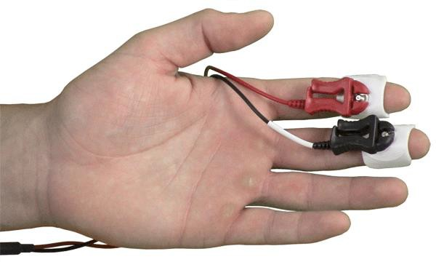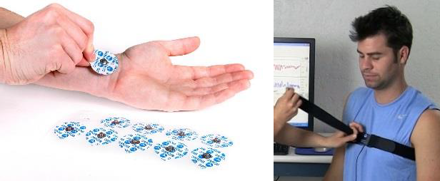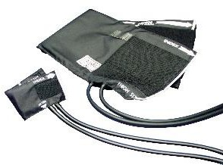
Figure 1a Figure 1b Figure 1c Figure 1d
Figure 1. BIOPAC accessiories (source: https://www.biopac.com/wp-content/uploads/Respiration-Belt-Setup.jpg)
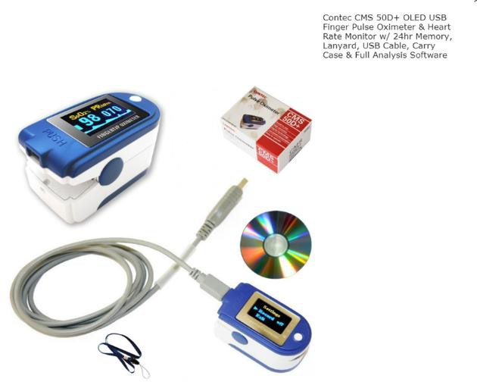
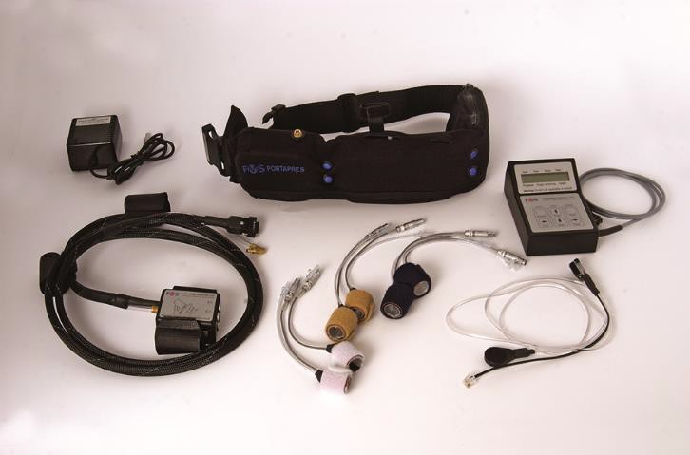
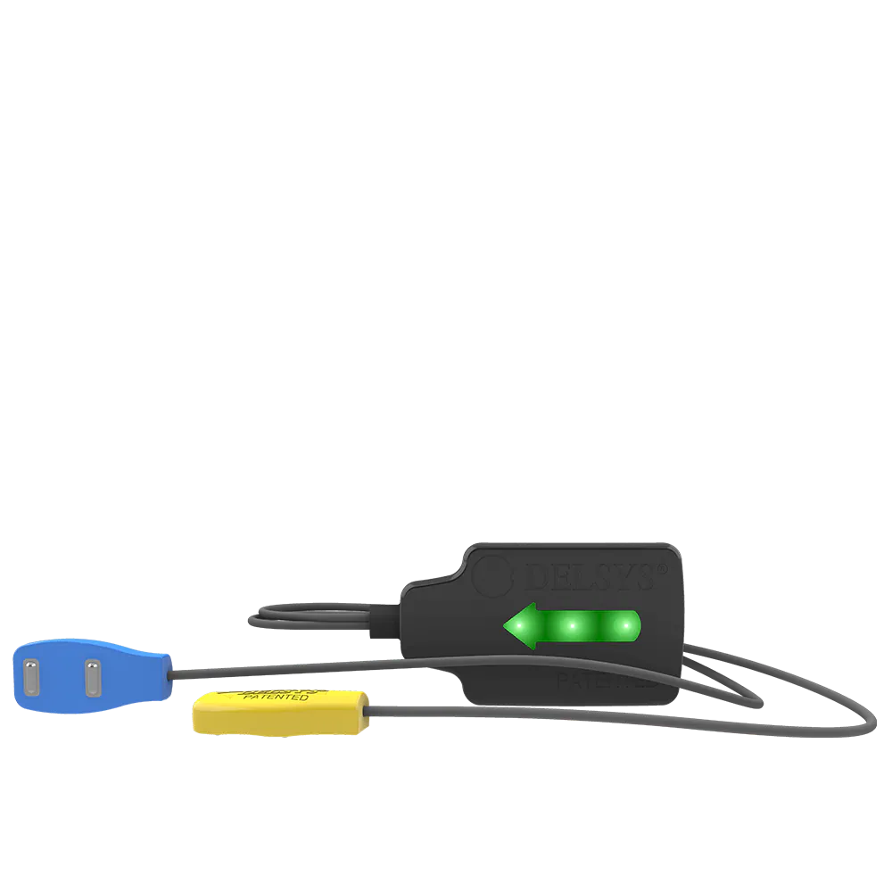
Other systems:
The Delsys Inc. equipment is used to record surface EMG using a re-usable electrode that attaches to the skin with single-use replaceable stickers; the electrode is disinfected after each use (see Figure 2). The CONTEC CMS 50D+ OLED USB Finger Pulse Oximeter and Heart Rate Monitor and the Portapress system (see Figure 2) which also record heart rate and blood pressure using a simple finger cuff. The CONTEC and Portapres systems satisfy medical safety standards.
Figure 2. Delsys Inc.EMG electrode (left), the Contec CMS (middle) and Portapres system (right).

Psychology undergraduate students at Stirling are trained in conducting research in their second year of study typically with the use of the BIOPAC system. BIOPAC equipment is also set up for demonstrations with volunteers during University Open Days including school visits. Physiological data may be collected by members of teaching and research staff and by students for third (PSYU9AC) and fourth (PSYU917) year undergraduate research projects, as well as for master’s and PhD research. This approved protocol procedure is intended to be used for all cases of physiological recordings involving healthy adult volunteers and not for clinical populations or diagnoses. The British Psychological Society guidelines will be followed for specific projects that involve participants under the age of 18 years. *Note that teaching labs and University Open Day demonstrations are with EDA, EMG and/or ECG only, while research may include any single or combination of the physiological measures described above.

TRAINING
All undergraduate students are trained in the use of the BIOPAC equipment in their second year, as are MSc Psychology (conversion) students who use the equipment for research. When using the BIOPAC system as part of a dissertation, undergraduate students receive a refresher from one of the technicians in Psychology, who are also available during working hours to provide support. In all cases, the student supervisor will ensure adequate training has been completed. Technicians are also available to provide training for researchers who are new to the system.

INFORMATION PROVIDED TO PARTICIPANTS
The specific details provided to participants will vary depending on the study, but will always be given using our information sheet template (see attached), and will always include:
- the name of the study;
- the most recent date and the version number of the information leaflet that has been approved by the Ethics Committee in the header/footer;
- the name(s) and status(es) (e.g. doctoral student) of the researchers carrying out the study and how to contact them;
- a brief rationale of the study, including its purpose and value;
- why potential participants are being invited to take part in the research (e.g. because they are residents of a particular place, users of a particular facility, speakers of a particular language);
- an explanation of what participation involves, including estimated duration of the testing session and location;
- that potential participants can ask questions about the study before they decide whether to participate;
- that participation is voluntary and, if they agree to take part, they may withdraw from the study without penalty at any time by advising the researchers of this decision (if the potential participants are students there should be particular reassurance that there is no academic penalty for non-participation or withdrawal, i.e., withholding course credit);
- information about any additional personal information that would be obtained;
- information about who will have access to the data, how it will be stored and what will happen to the data at the end of the study;
- statement that the data will be anonymised;
- what benefits (direct or indirect) may accrue to the participants in the study;
- what risks are involved in the study;
- that the project has received ethics clearance through the University of Stirling’s ethical approval process for research involving human participants;
- where applicable, a note to explain that the research will be written up as a student’s thesis and how the personal data included in that thesis will be published and stored;
- the procedure for raising a concern or making a complaint;
The information leaflet should be written in simple language that is understandable by a 12-year-old. Word processing packages are available to assist with ensuring a suitable reading age.

CONSENT OF PARTICIPANTS
All participants will always sign a consent form which will be given using our consent form template (see attached), and will always include:
- the name of the study;
- the most recent date and the version number of the information leaflet that has been approved by the Ethics Committee in the header/footer;
- the name and status (e.g. doctoral student) of the researcher collecting the information and how to contact him/her;
- declarations that the participant:
- has read the participant information sheet with the version number and date that was approved by the Ethics Committee;
- has had the opportunity to ask questions about the study and has received satisfactory answers to questions, and any additional details requested;
- understands that s/he may withdraw from the study without penalty at any time by advising the researchers of this decision;
- understands that this project has been reviewed by and received ethics clearance through the University of Stirling’s Research Ethics Committee;
- understands who will have access to personal data provided, how the data will be stored, and what will happen to the data at the end of the project;
- understands how to raise a concern and make a complaint;
- agrees to participate in this study.
Participants will initial boxes, print and sign their name, including the date. The researcher obtaining consent will also print and sign their name and date the form.

FINANCIAL AND OTHER REWARDS TO PARTICIPANTS
Participants may be compensated for their time with either course credit (via psychweb previously approved both by GUEP and NICR) or money at a rate approved by the University of Stirling.

POTENTIAL RISKS TO PARTICIPANTS/RESEARCHERS/OTHERS
Identify and outline steps taken to minimise risks

Risks to participants
Recordings of heart rate, electrodermal activity, respiration and blood pressure have been used safely for many years, and we are aware of no cases of adverse effects of participation. Equipment comes from certified suppliers of medical equipment, who are obliged by law to adhere to published guidelines on electrical and mechanical safety (IEC-6060-1). During the session, participants are asked to indicate if they feel any discomfort, in which case the procedure is stopped. The procedure can be paused if the participant needs to take a break, visit the bathroom, or if a fire alarm sounds.
Physiological measures recorded with BIOPAC vary widely from individual to individual. Researchers are strictly advised not to make any judgmental comments on the recordings seen in individual participants, to avoid causing unnecessary anxiety. For blood pressure experiments only, blood pressure readings taken at the start of the experiment will be noted on the participant debrief sheet with the statement below.
“At the start of the research, your blood pressure readings were as follows: systolic pressure ___ and diastolic pressure ___.”
Participants are advised that if they wish they can check what their reading means on the NHS website (https://www.nhs.uk/health-assessment-tools/check-your-blood-pressure-reading/enter-reading). At the University of Stirling, recordings of acute changes in EDA, EMG, ECG, respiration and blood pressure are used to infer psychological processes, and cannot be used for clinical diagnoses.
Participants will be informed that the researchers at Stirling are not trained to detect abnormal recordings. Furthermore, physiological recordings collected at the University of Stirling are not appropriate for or used to diagnose medical conditions. Participants are advised (see Participant Information Sheet) that if participation in the experiment has raised any concerns about the physiological variables in the experiment (e.g., EDA, EMG, ECG, respiration or blood pressure) they should seek formal medical advice through self-referral to their GP.
Lastly, equipment is kept hygienic: single-use electrodes are disposed of after use, and equipment that comes in contact with participants (e.g., finger cuff) is disinfected using antibacterial wipes after use. Electrodes are not placed over injured skin.

Risks to researchers
The primary way to avoid risk is to adhere to a hygiene regime, with researchers washing their hands before and after any contact with the participants.

MONITORING AND REPORTING OF ADVERSE OR UNFORSEEN EVENTS
If a participant becomes unwell during the testing session, the session will be terminated. Any such incidents will be recorded in the Stirling University Accident Management System (https://app.workrite.co.uk/AmsUi/ReportIncident.aspx). Emergency assistance including first aid is available via the SafeZone app or by calling the security (7999 from internal line/Teams or 01786 467 999 from an external phone).

DISCLAIMER
The following information shall be included in the Participant Information Sheet:
“Please note that researchers at Stirling are not trained to detect abnormal recordings. Furthermore, physiological research recordings at the University of Stirling cannot be used to diagnose medical conditions.”

DATA PROTECTION ISSUES
Each participant is given a participant code/number, which, rather than their name, is used to label all study data, including computerised recording files and any paper records. If it is necessary to retain any personal information (e.g., contact details for participants who may be re-tested), the key linking participant codes to personal details will be stored on a password-protected computer within a designated private and secure SharePoint site.

CHANGE HISTORY:

Version  No. | Significant Changes | Previous Version No.
1.1 | Electromyography (EMG) and electrocardiology (ECG) added; updated equipment used | 1.0
Date of Review |  | 31.03.2026
Date for Next Review

[Study Title]
PARTICIPANT INFORMATION SHEET
Approval Reference: [Insert]

We would like to invite you to take part in a research project. Before you decide, it is important for you to understand why the research is being conducted and what it will involve. Please take time to read the following information carefully. If there is anything that you do not understand, or if you would like more information, please ask us. Thank you for reading this.

What is the purpose of the research?
[Add information about your study.]

Why have I been invited to take part?
[Add information about your participant group.]

Do I have to take part?
No. It is up to you to decide if you want to take part in this study. We will describe the study and go through this information sheet with you to answer any questions you may have. If you agree to take part, we will ask you to sign a consent form, and will provide you with our contact details and a description of the purpose of the experiment, in case you have any further questions. It is important for you to know that you are still free to withdraw from the study at any time, without needing to give a reason and without penalty.

What will happen if I take part?
The researcher will attach two rectangular electrodes to the fingers of your non-dominant hand (one on the index finger and one on the forefinger) to record skin conductance. If muscle activity is recorded, then the experimenter will attach two electrodes over the muscle where the signal is going to be recorded from and a third, additional electrode somewhere near the other two. In some cases, when recording muscle activity over an area where there is a lot of hair present (e.g., a forearm) the researcher may ask to shave the hair from the skin before attaching the electrodes; in this scenario the researcher will inform you beforehand and will use a single-use razor which will be disposed after use. In addition, two circular electrodes will be attached to either of your wrists to record heart rate. Your skin may be cleaned with medical alcohol wipes before the electrodes are attached (or you may be asked to wash your hands) to help improve the signal quality. An adjustable elasticated belt will be secured around your abdomen to record respiration. A finger or an arm cuff (delete as appropriate) will be secured around your fingers or arm to record blood pressure. If you feel uncomfortable with the researcher securing the electrodes, belt and/or blood pressure cuff then the experimenter will demonstrate and instruct you how to do this yourself. The electrodes are made of foam (some electrodes may contain vinyl) and are self-adhesive; they secure to the skin as a sticker. Each electrode contains conductive gel to facilitate the recording of your physiological data. This gel is hypoallergenic, water-based and is easily washed off with warm water. Please use the washrooms to rinse any residue away immediately after the experiment. When the electrodes are removed there may be some temporary marks from the self-adhesive sticker; these marks should not cause any concern and will fade after a short time.
We ask you to let the researchers know if the procedure becomes uncomfortable at any point. In this case, we will terminate the study procedure, without this having any negative consequences for you.

Are there any risks in taking part in this study?
The recording of electrodermal activity, muscle activity, heart rate, respiration and blood pressure (delete as appropriate) is harmless, painless and carries no significant risk to the participant. The nervous system activity has been recorded safely for many years, and we are aware of no cases of adverse events. All our equipment comes from certified suppliers of medical equipment, who are obliged by law to adhere to published guidelines on electrical and mechanical safety (IEC-6060-1). If you feel any discomfort, then please let the researcher know and they will stop the procedure.
It is important to note that these recordings are carried out only for research and not for diagnostic purposes. If you think you may have an undiagnosed medical condition affecting your basic physiological responses (e.g., heart rate or breathing) then you should consult your GP and you should not take part in this study. University of Stirling researchers are not qualified nor have the appropriate information to comment on your health status based on the physiological variables recorded in this experiment. You should also not take part in this study if you have any skin conditions or injuries that could get infected through contact with the electrodes.

Are there any benefits from taking part in this study?
No. There will not be any direct benefits to you in this study.

Will the cost of my time be reimbursed?
Yes, you will be compensated with tokens for course credit and/or £ for your time.

Who has reviewed this study?
All research studies are checked by an ethics committee to ensure that the research is conducted safely and to the best standards. This research has been reviewed by, and received favourable opinion through, the University of Stirling Research Ethics Committee (NICR and GUEP panels).

What will happen with my data?
Any information collected about you during this study will be kept strictly confidential. Any physiological and electronic data will be anonymised with a code so that the results cannot be linked back to you. All such data are kept in firewall and password-protected computers and any information on recorded on paper (such as your contact details and any research questionnaires) will be stored safely in locked cabinets. Responsible members of the University of Stirling may be given access to the data for monitoring and/or auditing purposes to ensure we are complying with guidelines. Sometimes, new methods to analyse data become available after a study has ended. Therefore we would ask for your permission to use your anonymised data in future studies, and to share data with other researchers both inside and outside the European Union. We plan to publish the results in a scientific journal, but would not normally give feedback about results to individual participants. Information about published papers can be found on our website (www.xxx.xxx). (Delete as appropriate.)

What if there is a problem?
If you have any concerns about any aspects of this project, please speak to the relevant researcher [insert email here] or their supervisor (where applicable). You may also contact Professor Paul Dudchenko (p.a.dudchenko@stir.ac.uk), should you have any comment or concern that you wish to refer to an independent faculty member. If you remain unhappy or wish to make a formal complaint, please contact the Research Ethics Committee at the University of Stirling (general queries, ethics@stir.ac.uk) who will seek to resolve the matter in a reasonably expeditious manner.

PARTICIPANT CONSENT FORM
Approval Reference:
[Study Title]

Please initial each
box
1 | I confirm that I have read and understand the information sheet for the above  study. I have had the opportunity to consider the information, ask questions and have had these answered satisfactorily.
2 | I understand that my participation is voluntary and that I am free to withdraw at  any time, without giving any reason, and without penalty.
3 | I understand that research data collected during the study may be looked at by  designated individuals from the University of Stirling where it is relevant to me taking part in this study. I give permission for these individuals to access my data.
4 | I understand who will have access to the personal data provided, how the data will be  stored and what will happen to the data at the end of the project.
5 | I understand that this project has been reviewed by, and received ethics clearance  through the University of Stirling Research Ethics Committee.
6 | I understand that the recordings in this experiment are not useful for medical  diagnosis.
7 | I understand how this research will be written up and published.
8 | I understand how to raise a concern or make a complaint.
9 | I agree to take part in the above study.
Optional: | I agree for my personal data to be kept in a secure database for the purpose of  contacting me about future studies.

Name of participant |  | Date |  | Signature
Name of the person taking consent |  | Date |  | Signature

Debrief

Thank you for participating in this study!
The purpose of this experiment was to examine the effect of (insert psychological variable/s) on (insert physiological variables measured inc. heart rate, electrodermal activity, respiration and blood pressure). Previous research has shown that mental/emotional (xxx delete as appropriate xxx) arousal during a (insert name or description of task) produces observable changes in (insert variables here). Our aim was to further investigate the relationship between these variables.
Please note that researchers at Stirling are not trained to detect abnormal recordings. Furthermore, the physiological research recordings at the University of Stirling are not appropriate or used to diagnose medical conditions. If participation in this experiment has raised any concerns about your physical health (including heart rate, electrodermal activity, respiration or blood pressure), please seek formal medical advice through self-referral to your GP.
If your blood pressure was recorded at the start of the experiment the readings are recorded below:
Your blood pressure readings at the start of the research were as follows: systolic pressure was ___ and diastolic pressure was ___. You can check what this means on the NHS website (https://www.nhs.uk/health-assessment-tools/check-your-blood-pressure-reading/enter-reading) by googling ‘NHS Blood Pressure’.
Please note that these readings were not taken under clinical conditions and may have no diagnostic value. The researchers are not clinically trained and are unable to comment on the readings. If you are concerned about your blood pressure you should contact your GP.
If you wish to withdraw your data please inform the experimenter now or e-mail within one week from today. If you choose to withdraw your data from the study it will not be used in any analyses and all electronic files will be permanently deleted from the computer and associated hard drives, and all paper documentation shredded.
If you have any additional questions about this study or wish to withdraw your data, please e-mail (insert e-mail of researcher) or (insert e-mail of additional researchers). You may also contact Professor Paul Dudchenko on (p.a.dudchenko@stir.ac.uk), should you have any comment of concern that you wish to refer to an independent faculty member.

