fNIRS Protocol Version 1.0
Psychology Division, University of Stirling

Version history:

  - (28/11/17) – Authors: Sobanawartiny Wijeakumar, Yee Lee Shing, Eva Rafetseder

Standard Research Protocol Ethics approval history:

There are four sections to this document:

    - Introduction
    - Treatment of Research Participants

    - Laboratory Procedures

    - Declaration

    - Appendices:

- Participant information sheet template for fNIRS experiments
- Consent form template for fNIRS experiments

Introduction

    - Introduction to functional near infrared spectroscopy

Functional near infrared spectroscopy (fNIRS) is an optical imaging technique that relies on the principle of shining near infrared range light (695-1000 nm) through scalp and brain tissue.
Light is shone through sources placed on the surface of the head and is differentially absorbed by oxy and deoxy-hemoglobin concentration in blood. The remaining light is detected by detectors placed some distance away from the emitters on the surface of the scalp. Hemodynamic activation is measured from the region between each source and detector. fNIRS is a portable neuroimaging technique that is more tolerant of head movements (unlike functional magnetic reasonance imaging [fMRI]) since the sources and detectors are attached to the surface of the head. Moreover, safety concerns are minimal since infrared light is common in the environment. Furthermore, unlike fMRI, fNIRS is not loud or frightening and does not require the participants to lie in an uncomfortable supine position for an extended period of time. Thus, fNIRS is ideally suited as a cognitive neuroscientific technique for use with infants, children, young adults, and older adults (for

review, see Scholkmann et al., 2014; Wijeakumar, Huppert, Magnotta, Buss, & Spencer, 2017, Wijeakumar, Magnotta, & Spencer, 2017).

1.2. Standard Research Protocol: Best practice

This protocol serves as a template for fNIRS studies and demonstrations to be conducted within the Psychology Division at the University of Stirling. The document will be honed and adapted over time and the first few iterations are intended to be a starting point for documenting best practice for use of the fNIRS laboratory. Note that this starting point is based on an already approved research protocol at the University of East Anglia, whose PI John Spencer has six years of experience using fNIRS (Buss, Fox, Boas, & Spencer, 2014; Wijeakumar, Huppert, et al., 2017; Wijeakumar, Magnotta, et al., 2017) in the United States and the United Kingdom, and whose collaborator, Dr Wijeakumar, is an author on this protocol application. Familiarisation with this document is a necessary part of training for users of the fNIRS laboratory. In addition, it is necessary for someone who has never run an fNIRS experiment to be supervised by someone else more experienced for several recording sessions. The contact information of staff members and of the PSY technicians will be available in the lab, if needed. The current focus of this protocol lies on ethical considerations that are associated with fNIRS experiments (potential discomfort for participants). Future versions are likely to add more detailed technical instruction sections.

1.3 Standard Research Protocol: Ethical Approval

The document contains information regarding the ethical treatment of participants in fNIRS studies. The protocol has been approved by the NHS Research Ethics Committee (NICR) at the University of Stirling as a ‘Standard Research Protocol’. You must: (a) sign and append the latest version of this document to your General University Ethics Panel (GUEP) Application Form, (b) refer to this document in Section A11 (Supporting documentation) and

in Section B7 (Potential ethical issues), and (c) outline any deviation from this protocol in space provided at the end of this document. Therefore you do not need to describe the fNIRS procedure itself in the ethics application.

Treatment of Research Participants

  - Participants

The age of the participants will vary from 3 months to 80 years of age. Participation reimbursement follows the PSY Standard Payment / Psychweb token allocation rates for the duration of the participant’s stay in the laboratory (i.e. including enough time for a comprehensive debrief). Child participants will be recruited via local nurseries/schools. With nursery director’s/head teacher’s consent, formal letters of invitation will be given to parents. Letters request that interested parents contact us at which point we can answer questions and arrange an appointment. We will also recruit families by posting a description online, and by attending community events.

Ethical considerations

The system we employ, NIRSport, uses low power NIR LED illumination and is deemed eye and skin safe as attested in the attached independent lab report (Appendix A). The report was generated with LED sources identical to the ones used with NIRSport, under the same operating conditions (max. brightness and driving waveform). The wavelengths used are 760nm and 850nm. Despite it being considered non-invasive and non-hazardous, a number of ethical considerations should be taken into account and be carefully communicated to the participant.

The participant may experience mild discomfort from the following:

- Participants will be asked to try and sit still whilst they are carrying out the experimental tasks. Since cables will be attached to the participants, the ability to move around before the end of the experiment is limited.
- To set up the fNIRS cap, the experimenter(s) will be in the participant’s close personal space and will touch the head and face whilst taking head measurements and setting up/adjusting the cap and optodes.
- A chinstrap will be used to secure the cap in place.
- While the procedure itself does not cause any discomfort, infants and children who are unaccustomed to wearing hats might find the cap uncomfortable.
- Some infants might be required to sit in a high chair.

- Once the cap is on, we ask the participants to refrain from moving a lot as it causes the fibres to move and introduces motion artifacts in the data.

Discomfort will be minimised by these steps:

- Participants/Guardians will be informed about the fNIRS procedure when they are invited to the experiment. They will be informed about potential mild discomfort, but be reassured that it is a non-invasive and non-hazardous procedure. Clear directions to the lab should also be provided at this stage.
- Upon welcoming a participant/guardian to the lab, a ‘tour’ of the facility should be given.

- It should be ensured that participants/parents read the information sheet (see Appendix B) and sign the consent form (see Appendix C) before setting them up. They should be explicitly reminded that participation is voluntary and that they have the right to withdraw at any time.
- The Experimenter will be friendly and will talk to the participant/guardian throughout. Every single step will be explained before it is performed. This is critical especially for steps that involve physical contact between the experimenter and participant/parent.

- The experimenter will make sure the participant is sitting comfortably, explaining how long they will have to sit in that position.
- The cap size will be determined by the participant’s own measurement of their head, and through re-measurement by an experimenter. The cap should fit tightly onto the scalp, but not so tight that the cap is uncomfortable.
- If the infant/child starts getting distressed during the period when the cap is being placed or when the optodes are being put in, attempts will be made to distract the child (i.e., reorienting their attention to a video or engaging them with toys and infant or child- directed speech) until the fitting and calibration are complete.
- Breaks will be taken as needed and snacks can also be provided to the participant.

Ensuring participant comfort and signal quality through communication

- Tell the participant that we will only be recording activity naturally occurring in their brain, not stimulating any part of their brain.
- Make sure the participant is comfortable and relaxed.

- Tell them about breaks: when they happen in your task, and that they can ask for more if something is not right or the infants/child starts to get distressed.
- If the infant/child starts to get overtly distressed, experimentation must stop immediately and the cap will be taken off.
- Make sure the participant does not start the sequence before being given the instructions.

- Explain during set-up what the set-up screen is showing.

- Carefully remove the cap from the participant’s head at the end of the experiment.

- The participant must know where an experimenter is at all times, and how they should communicate with them, from set up to dismissal so that any discomfort can be remedied immediately.

Compensation of participants in case of cancellation due to the experimenter

In case a recording has to be cancelled due to the experimenter or malfunction of the equipment, participants will be compensated to a minimal amount equivalent to the 1st hour (e.g., if the experiment is cancelled right away) and are paid for their time if the experiment is cancelled at a later stage.

Laboratory Procedure

    - Before testing

Greeting the participant and initial paperwork

        - The relevant paperwork such as the study’s consent form, fNIRS consent form (Appendix D), payment form and questionnaires need to be filled out by the guardian if the participant is under 18 years of age.
        - After consent has been obtained, measure the head circumference (in cm): participant/parent can send this info through e-mail using their own measuring tape if they have one (see Appendix E).
        - Adult participants may also fill out any questionnaires during this time.

Positioning the cap:

      - Participants may be seated in front of the screen while the cap is fitted.

      - Place the cap on the participant. Measure the distance between the nasion (top of the nose) to inion (bump at the back of the head). Locate the midline point (half distance between the inion and nasion) – see Figure1. This point is called Cz.

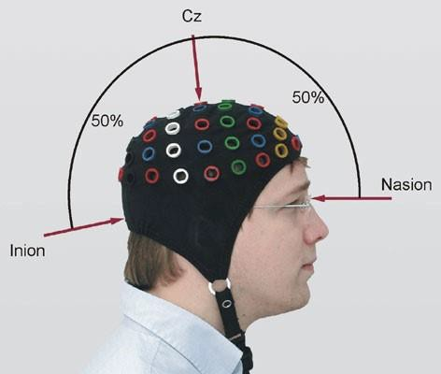
Figure 1. Correct placement of the cap.

      - Measure the distance between the peri-auricular points at the left ear (point Al) and the right ear (Ar).
      - Make sure the position of Cz, using both sets of distances (inion–nasion and peri- auricular points) lies directly underneath the Cz position marked on the caps. If not, move the cap to ensure proper placement.
      - A temporary marker might be used to mark the places on the forehead where the cap is positioned. This is for reference if the cap slips back after the sources and detectors are inserted. The cap should be centred when standing in front of the participant: midline electrodes like Fz, Cz, Pz should be aligned with the nose.
      - Take a hair pin and clear the hair gently underneath each optode position so as to expose the scalp and allow more contact with the scalp surface. The sources and detectors will then be inserted into the correct grommets in the cap. Note that for young infants, we will have the optodes pre-loaded into the cap to reduce the time required to place the cap on the infant’s head and start the session. This works well since hair is generally not a concern with this age group.
      - Make sure the strap under the chin is tight enough: the participant should be able to breathe normally (!) but the cap should not move (see Figure 2).

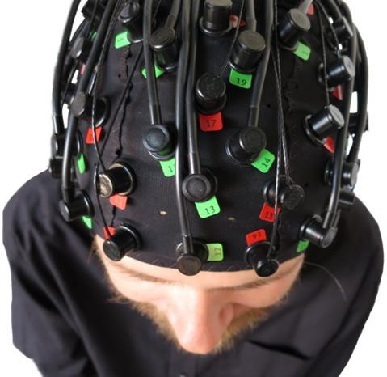

Figure 2. Cap and optodes. Sources are in red and detectors in green.

      - The fiber optic cables leading from the sources and detectors to the fNIRS system should be handled with care as they are expensive and cannot be bent. Bending can cause microfractures which limit the transfer of light to and from the head.
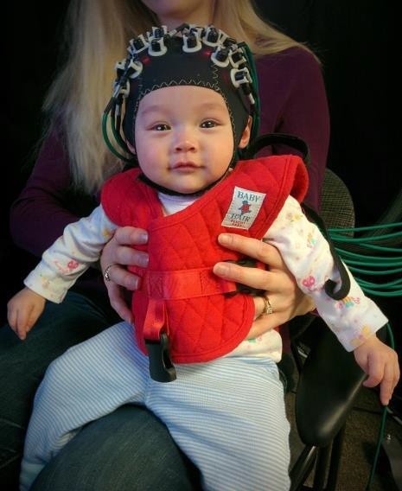
Figure 3. Example of cap and optodes used with young infants.

During the session

Digitizing:

        - The Polhemus Patriot Motion sensor will be used to digitize the scalp landmarks and the locations of the sources and detectors.

        - The reference is attached to the Cz location on the cap.

        - The motion sensor wand is held pointing towards the left temple whilst the Polhemus box is switched. This is done for calibrating the machine.
        - After calibration and checking the parameters on the software, the digitization process begins.
        - The wand is moved from location to location and the button on the side of wand clicked at to register the x,y and z coordinates of that particular location.
        - The order of the locations is as follows : Nasion, right peri-auricular, left peri-auricular, Cz and inion, sources in order and finally, detectors in order.
        - The coordinates that appear on the screen in the software are to be copied to a text file and saved.
        - This digitization process has to be carried out before and after the experimental paradigm to account for any movement in the cap during the duration of the experimental paradigms.
        - Pictures of the participant should be taken before and after the experimental paradigms to supplement the digitization process.

Data Collection:

- Turn NIRSport on.
- Double click NIRSport icon from the local PC desktop
- Select your probe configuration from SD templates
- Hit start, and check the signals

What should you do to improve the signal?

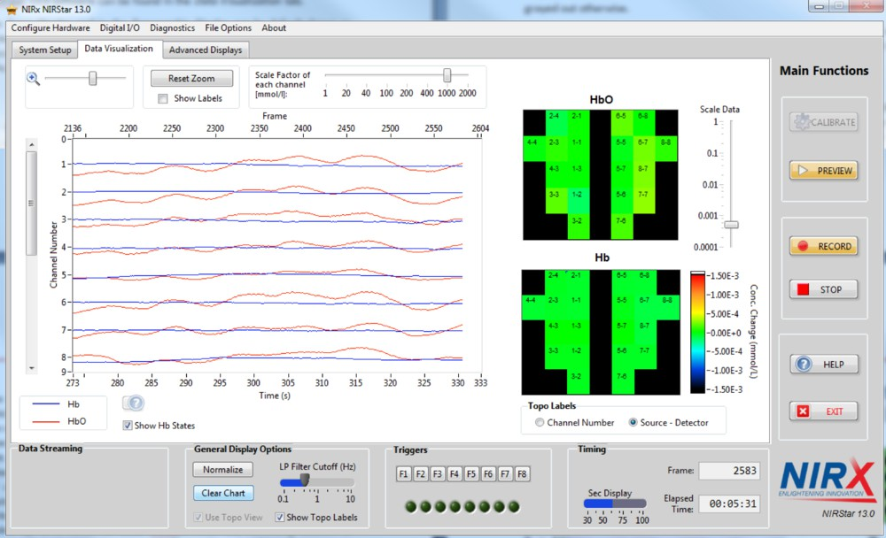

Figure 4. Data acquisition software. Green boxes indicate good signal.

  - Remove the sources and detectors of those channels that show noisy signals and move hair gently using a hair pin.
  - Cover the cap with a bandage to stablize the contact between the sources and detectors and the scalp.
  - Cables/fibers should not touch the subject’s shoulder and be relatively taut to reduce motion artifacts.

Hit Stop after each experimental task and the data will be autosaved on a local desktop.

Running experiment paradigm

  - Open experiment file
  - For E-prime, click Run

  - Enter participant’s code

  - Save in the appropriate folder on desktop

  - For Director, run the executable
  - Enter participant’s code

  - Save in the appropriate folder on desktop

After Data collection

- Usually, the experimenter takes the cap off. With older children and adults, participants are sometimes invited to assist to keep hair from getting caught.
- The participant/parent will receive the full debrief as normal and offered the opportunity to ask any questions. Children will receive a reward for participating. Payment details will be confirmed with participants/parents as well. Then participants/parents will be shown out of the building.
- After the session is complete, the optodes are removed from the cap and it is washed with a mild shampoo in the lab sink and left to dry on a rack at a designated spot.
- fNIRS data files (.nirs format) should be saved to the assigned server space.

- All AV files are saved to the assigned space on the AV network.

- Participant session sheets should be completed, including notes on how the session went. All paperwork should be filed appropriately.

Declaration

This fNIRS study follows the standard procedure as described in this protocol
My fNIRS study follows the standard procedure as described in this protocol except in the following respect(s):

I have read and understood the ethical and technical issues that are associated with fNIRS studies as described in this protocol.

I have received adequate training in this technique and I am familiar with the procedures.

Principal Investigator:
Signature: Date:

Student (if applicable):

Signature: Date

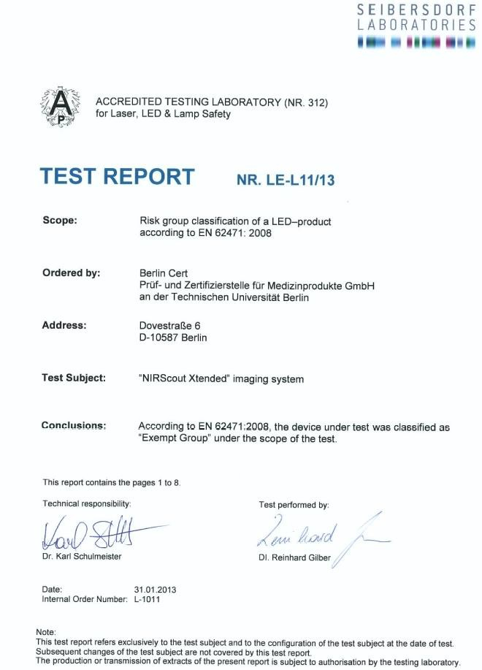
APPENDIX A: Independent lab report


APPENDIX B: Participant information sheet template for fNIRS experiments

PI: [INSERT YOUR NAME]
Direct Line: [INSERT YOUR PHONE NUMBER] E-Mail: [INSERT YOUR EMAIL]

[INSERT TITLE]

INFORMATION SHEET FOR PARTICIPANTS
Ethics Approval Reference: GUEP [INSERT NUMBER]

Thank you for your interest in this study. We very much hope you would like to take part, but before you decide, it is important that you understand why the study is being done and what it will involve. Please read the following information carefully (this sheet is for you to keep). You may ask me any questions if you would like more information.

What are we trying to find out?
[Please write a brief description of your research. You might explain why the participants have been chosen.]

Do I have to take part?
It is up to you to decide whether you join the study. We will describe the study and go through this information sheet. If you agree to take part, we will then ask you to sign a consent form. You are free to withdraw your participation at any time, without giving a reason. This would not affect you in any way. Likewise we can stop the study at any time if you feel uncomfortable or unhappy. You can also withdraw your data from the study up to two weeks later by contacting us by phone or email indicating that you would like the data withdrawn.

What will happen if I agree to take part?
If you agree to take part, the procedure will entail recording your brain activity using functional near infrared spectroscopy (fNIRS). fNIRS is a safe and non-invasive technique that measures blood flow in the brain (an index of brain activity) using sources and detectors placed on the scalp.

fNIRS – head measurement. fNIRS involves measuring your head to choose an appropriate cap. We will then place the cap on your head and attach some sources and detectors to it. We will tell you at each point what we are doing. During set-up, we will also carefully part your hair beneath the sensors on the cap – this may involve making contact with your scalp, but should never hurt. We will ask you to provide feedback on any part of the procedure and will stop immediately if you feel uncomfortable at any point.

fNIRS – Movement. You will be invited to find a comfortable position in your chair; however, we will ask you to limit movement as much as possible. Your experimenter will give you very clear instructions about when it is OK to move and when it is best to keep as still as possible, but ask for clarification if anything is not clear. We will give you breaks and food/snacks will be available whenever you need it, but please ask for additional breaks as needed.

fNIRS – Brain measurement. fNIRS only allows us to record blood flow activity naturally occurring in your brain. It does not stimulate any part of your brain, nor does it allow us to “read your mind”. It will not – and cannot – be used to diagnose any condition. If you wish to receive more information about fNIRS before you decide to take part, please feel free to ask us. The experiment will take [xxx] hours.

Are there any problems with taking part?
The placement of the fNIRS cap is not painful, although there may be minor discomfort. If you experience any discomfort during the study, please let us know. In addition, please know that you can ask for a break or choose to stop at any time.

Will it help me if I take part?
You will not benefit personally from being in this study. However, in the future, other people might benefit from this study. Our hope is that the information obtained from this study will lead to [INSERT TEXT].

[Additional Headings: Details on any particular features of the study – e.g. video/audio recording; details of any potential disclosure (e.g. if failure to disclose might lead to harm); You should also explain if payment is used and how].

How will you store the information that I give you?
All information which you provide during the study will be stored in accordance with the 1998 Data Protection Act and kept strictly confidential. The chief investigator will be the custodian of the anonymous research data. Any identifiable data will be stored separately in a password protected file and will be securely disposed of as soon as it is no longer necessary. All anonymized results will be stored indefinitely in order to comply with open practice standards.

To help protect your confidentiality, each participant will be assigned a unique identification code that will be used in place of your name to identify all study data. The master list connecting your name and assigned code will be stored separately in locked storage. All study forms and recordings will be stored in locked file cabinets or in password-protected computer files. Only research team members will have access to these forms and recordings.

How will the data be used?

The results of the study will be published or presented at conferences or elsewhere. If we write a report or article about this study or share the study data set with others, we will do so in such a way that you cannot be directly identified.

What happens if I agree to take part, but change my mind later?
Taking part in this research study is completely voluntary. You may choose not to take part at all. If you decide to take part in this study, you may stop participation at any time. If you decide not to be in this study, or if you stop participation at any time, you won’t be penalised or lose any benefits for which you would otherwise qualify.

If you decide you would like to withdraw your data within the next two weeks, simply contact the lab via phone or email and give us your name.

How do I know that this research is safe for me to take part in?
All research in the University is looked at by an independent group of people, called a Research Ethics Committee, to protect your safety, rights, wellbeing and dignity. This research was approved by the General University Ethics Panel (GUEP) at the University of Stirling on [date].

What if there is a problem?
If you have a concern about any aspect of this project, please speak to the chief investigator. If you remain unhappy or wish to make a formal complaint, please contact the chair of the Research Ethics Committee at the University of Stirling.

What should I do next?
If you would like to take part in this study please fill in the enclosed form. Please remember that you are under no obligation to agree to take part in this research. If you do agree you can withdraw at any time without giving a reason.

Contact details:
If you have any questions or concerns about this research you can contact the principal investigator via [INSERT PHONE] or over email at [INSERT EMAIL].

You can also contact the Research Ethics Committee at the University of Stirling (Email: GUEP@stir.ac.uk; Address: General University Ethics Panel, University of Stirling, Airthrey Road, Stirling FK9 4LA).

APPENDIX B: Parent/Guardian information sheet template for fNIRS experiments

PI: [INSERT YOUR NAME]
Direct Line: [INSERT YOUR PHONE NUMBER] E-Mail: [INSERT YOUR EMAIL]

[INSERT TITLE]

INFORMATION SHEET FOR PARENTS/GUARDIANS
Ethics Approval Reference: GUEP [INSERT NUMBER]

Thank you for your interest in this study. We very much hope you would like to take part, but before you decide, it is important that you understand why the study is being done and what it will involve. Please read the following information carefully (this sheet is for you to keep). You may ask me any questions if you would like more information.

What are we trying to find out?
[Please write a brief description of your research. You might explain why the participants have been chosen.]

Do I have to take part?
It is up to you to decide whether you have your child join the study. We will describe the study and go through this information sheet. If you agree to your child taking part, we will then ask you to sign a consent form. You are free to withdraw your child’s participation at any time, without giving a reason. This would not affect you and your child in any way. Likewise we can stop the study at any time if your child feels uncomfortable or unhappy. You can also withdraw your child’s data from the study up to two weeks later by contacting us by phone or email indicating that you would like the data withdrawn.

What will happen if I agree to take part?
If you agree to take part, the procedure will entail recording your child’s brain activity using functional near infrared spectroscopy (fNIRS). fNIRS is a safe and non-invasive technique that measures blood flow in the brain (an index of brain activity) using sources and detectors placed on the scalp.

fNIRS – head measurement. fNIRS involves measuring your child’s head to choose an appropriate cap. We will then place the cap on your child’s head and attach some sources and detectors to it. We will tell you at each point what we are doing. During set-up, we will also carefully part your child’s hair beneath the sensors on the cap – this may involve making contact with your child’s scalp, but should never

hurt. We will ask your child to provide feedback on any part of the procedure and will stop immediately if your child feels uncomfortable at any point.

fNIRS – Movement. Your child will be invited to find a comfortable position in the chair; however, we will ask your child to limit movement as much as possible. Your experimenter will give your child very clear instructions about when it is OK to move and when it is best to keep as still as possible, but ask for clarification if anything is not clear. We will give you and your child breaks and food/snacks will be available whenever you need it, but please ask for additional breaks as needed.

fNIRS – Brain measurement. fNIRS only allows us to record blood flow activity naturally occurring in your brain. It does not stimulate any part of your child’s brain, nor does it allow us to “read your child’s mind”. It will not – and cannot – be used to diagnose any condition. If you wish to receive more information about fNIRS before you decide to take part, please feel free to ask us. The experiment will take [xxx] hours.

Are there any problems with taking part?
The placement of the fNIRS cap is not painful, although there may be minor discomfort. If your child experiences any discomfort during the study, please let us know. In addition, please know that you can ask for a break or choose to stop at any time.

Will it help me if I take part?
You will not benefit personally from being in this study. However, in the future, other people might benefit from this study. Our hope is that the information obtained from this study will lead to [INSERT TEXT].

[Additional Headings: Details on any particular features of the study – e.g. video/audio recording; details of any potential disclosure (e.g. if failure to disclose might lead to harm); You should also explain if payment is used and how].

How will you store the information that I give you?
All information which you provide during the study will be stored in accordance with the 1998 Data Protection Act and kept strictly confidential. The chief investigator will be the custodian of the anonymous research data. Any identifiable data will be stored separately in a password protected file and will be securely disposed of as soon as it is no longer necessary. All anonymized results will be stored indefinitely in order to comply with open practice standards.

To help protect your child’s confidentiality, each participant will be assigned a unique identification code that will be used in place of your child’s name to identify all study data. The master list connecting your name and assigned code will be stored separately in locked storage. All study forms and recordings will be stored in locked file cabinets or in password-protected computer files. Only research team members will have access to these forms and recordings.

How will the data be used?
The results of the study will be published or presented at conferences or elsewhere. If we write a report or article about this study or share the study data set with others, we will do so in such a way that your child cannot be directly identified.

What happens if I agree to take part, but change my mind later?
Taking part in this research study is completely voluntary. You may choose not to take part at all. If you decide to take part in this study, you may stop participation at any time. If you decide not to be in this study, or if you stop participation at any time, you won’t be penalised or lose any benefits for which you or your child would otherwise qualify.

If you decide you would like to withdraw your child’s data within the next two weeks, simply contact the lab via phone or email and give us your name.

How do I know that this research is safe for me to take part in?
All research in the University is looked at by an independent group of people, called a Research Ethics Committee, to protect your and your child’s safety, rights, wellbeing and dignity. This research was approved by the General University Ethics Panel (GUEP) at the University of Stirling on [date].

What if there is a problem?
If you have a concern about any aspect of this project, please speak to the chief investigator. If you remain unhappy or wish to make a formal complaint, please contact the chair of the Research Ethics Committee at the University of Stirling.

What should I do next?
If you would like your child to take part in this study please fill in the enclosed form. Please remember that you are under no obligation to agree to take part in this research. If you do agree you can withdraw at any time without giving a reason.

Contact details:
If you have any questions or concerns about this research you can contact the principal investigator via [INSERT PHONE] or over email at [INSERT EMAIL].

You can also contact the Research Ethics Committee at the University of Stirling (Email: GUEP@stir.ac.uk; Address: General University Ethics Panel, University of Stirling, Airthrey Road, Stirling FK9 4LA).

Appendix C: Consent form template for fNIRS experiments

PI: [INSERT YOUR NAME]
Direct Line: [INSERT YOUR PHONE NUMBER] E-Mail: [INSERT YOUR EMAIL]

[INSERT TITLE]

CONSENT FOR PARTICIPANTS
Ethics Approval Reference: GUEP [INSERT NUMBER]

Name of Researcher: [NAME OF CHIEF INVESTIGATOR]

Please initial all boxes

- I have read and understand the information sheet [information sheet title] and have had the opportunity to questions and have had these answered satisfactorily.

- I agree to participate in the fNIRS study, which involves to have sources and detectors placed in a cap which will be worn on my head. I understand that fNIRS only allows to record blood flow activity naturally occurring in my brain. It does not send or emit current.

- My participation is voluntary and I know that I am free to withdraw at any time, without giving any reason and without it affecting me at all. I understand breaks will be provided and that I can request additional breaks if needed.

- I know that no personal information (such as my name) will be shared outside of the research team or published in the final report(s) from this research.

[Additional statements may be required for use of transcripts/audio/video recordings, transfer of data out of the UK, receipt of individual feedback and as necessary]

- I agree to take part in the above study

Participant’s signature: Date:
Appendix C: Consent form template for fNIRS experiments

PI: [INSERT YOUR NAME]
Direct Line: [INSERT YOUR PHONE NUMBER] E-Mail: [INSERT YOUR EMAIL]

[INSERT TITLE]

CONSENT FORM FOR PARENTS/GUARDIANS
Ethics Approval Reference: GUEP [INSERT NUMBER]

Name of Researcher: [NAME OF CHIEF INVESTIGATOR]

Please initial all boxes

- I have read and understand the information sheet [information sheet title] and have had the opportunity to questions and have had these answered satisfactorily.

- I agree for my child to participate in the fNIRS study, which involves to have sources and detectors placed in a cap which will be worn on my child’s head. I understand that fNIRS only allows to record blood flow activity naturally occurring in my child’s brain. It does not send or emit current.

- My participation is voluntary and I know that I am free to withdraw at any time, without giving any reason and without it affecting me or my child at all. I understand breaks will be provided and that I or my child can request additional breaks if needed.

- I know that no personal information (such as my child’s name) will be shared outside of the research team or published in the final report(s) from this research.

[Additional statements may be required for use of transcripts/audio/video recordings, transfer of data out of the UK, receipt of individual feedback and as necessary]

- I agree for my child take part in the above study

Participant’s signature: Date:

Appendix D: Debrief form

[Study Name]

Thank you for participating in this study. Your time and efforts are much appreciated.

Explain the purpose of the study in lay terms without use of jargon. What were the predictions? If you used deception explain why.

If you have any questions regarding this study please feel free to ask or contact the chief investigator of this study now, or at a later date. Please note that we cannot diagnose any particular condition from the results of this study or tell whether someone is “normal” or not. If you wish to withdraw your data please contact the researcher [2 weeks deadline].

[Give details of sources of support where relevant, if participants are worried about their psychological health, then they should contact their GP in the first instance.]

If you would like to receive a report of the main findings of the study (or a summary of the findings) when it is completed please contact the researcher, however individual feedback on your results cannot be given.

Researcher: Name (email@stir.ac.uk) Supervisor: Name (email@stir.ac.uk)

Do also contact us if you have any worries or concerns about this research. [INSERT YOUR CONTACT DETAILS).

You can also contact the Research Ethics Committee at the University of Stirling (Email: GUEP@stir.ac.uk; Address: General University Ethics Panel, University of Stirling, Airthrey Road, Stirling FK9 4LA).

Thank you again for your participation.

Appendix E: Picture to send participants so that they can measure their head circumference

Use a message like: “If you have a tape measure at home, it would be useful for us to have a measure of your head circumference beforehand: simply place the tape around your head as indicated in the attached picture and send us the measure in cm. If you cannot or are not sure of how, please let us know and we will take the measure in the lab. Many thanks.
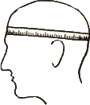

Appendix F: References

Buss, A. T., Fox, N., Boas, D. A., & Spencer, J. P. (2014). Probing the early development of visual working memory capacity with functional near-infrared spectroscopy. NeuroImage, 85, 314–
325. https://doi.org/10.1016/j.neuroimage.2013.05.034

Scholkmann, F., Kleiser, S., Metz, A. J., Zimmermann, R., Mata Pavia, J., Wolf, U., & Wolf, M. (2014). A review on continuous wave functional near-infrared spectroscopy and imaging instrumentation and methodology. NeuroImage, 85, 6–27. https://doi.org/10.1016/j.neuroimage.2013.05.004

Wijeakumar, S., Huppert, T. J., Magnotta, V. A., Buss, A. T., & Spencer, J. P. (2017). Validating an image-based fNIRS approach with fMRI and a working memory task. NeuroImage, 147, 204–
218. https://doi.org/ 10.1016/j.neuroimage.2016.12.007

Wijeakumar, S., Magnotta, V. A., & Spencer, J. A. (2017). Modulating perceptual complexity and load reveals degradation of the visual working memory network in ageing. NeuroImage, 157, 464–
475. https://doi.org/10.1016/j.neuroimage.2017.06.019

