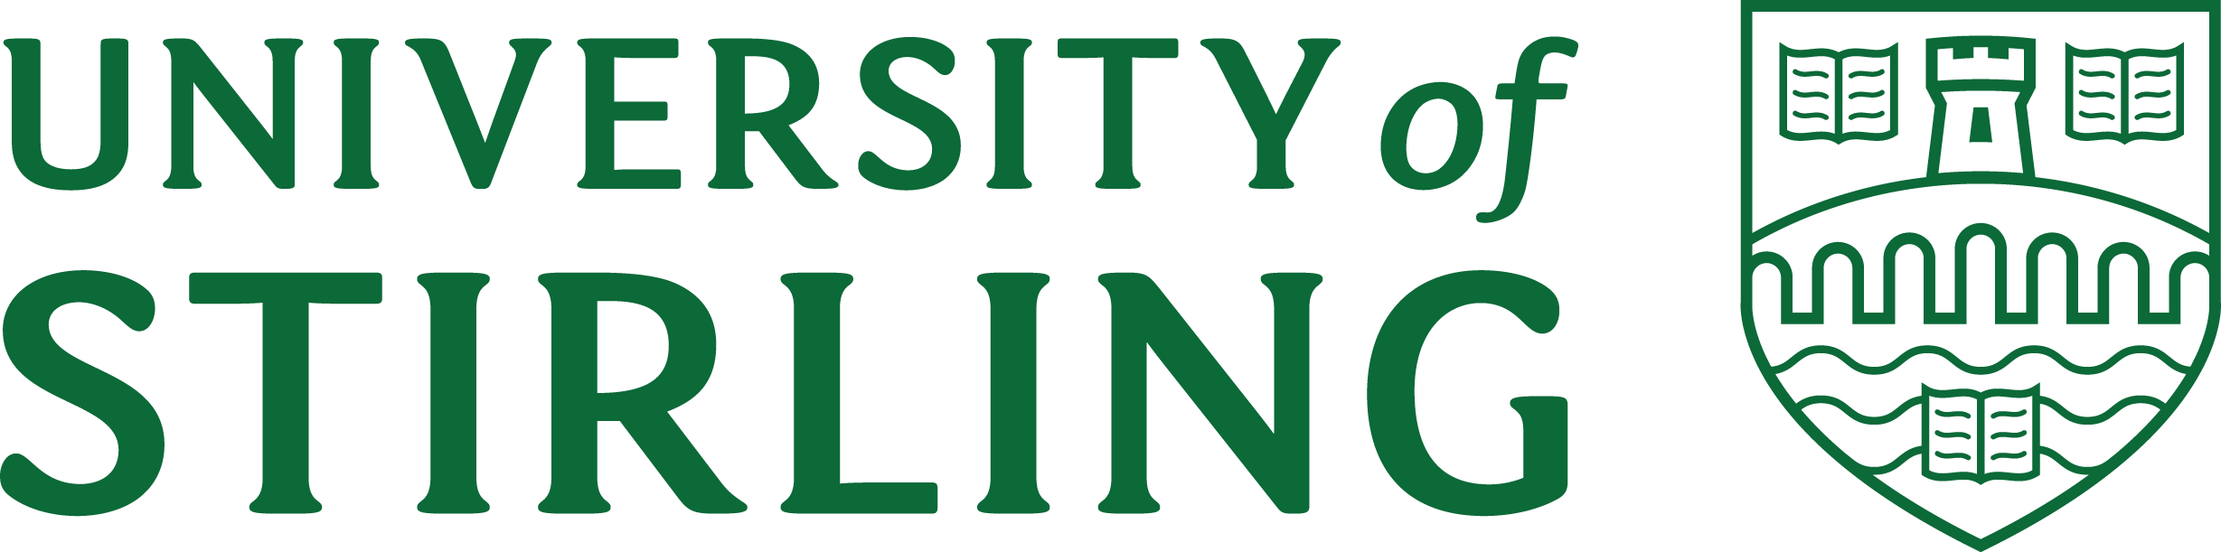

Academic Council membership 2026/2027

Principal
Professor Sir F Gerard McCormac

The Senior Deputy Principal
Professor Neville Wylie, Deputy Principal (Internationalisation)

The Deputy Principals
Professor Helen Scott, Deputy Principal (Education)
Professor Terri Scott, Deputy Principal (Student Experience)

Executive Deans/Deputy Principals
Professor Kirstie Blair, Faculty of Arts, Humanities and Social Sciences/Deputy Principal (Academic)
Professor Jayne Donaldson, Faculty of Health, Sport and Society, Deputy Principal (Health and Wellbeing)
Professor Kevin Grant, Stirling Management School, Deputy Principal (Entrepreneurship)
Professor Alistair Jump, Faculty of Natural Sciences, Deputy Principal (Research and Innovation)

Institutional Dean
Professor Iain Docherty, Dean for the Institute for Advancement

Elected Members
Six members elected by academic staff, from among the academic staff of the University holding professorial designation
Professor Edward Duncan, Faculty of Health, Sport and Society
Professor Louise McCabe, Faculty of Health, Sport and Society
Professor Gabriela Ochoa, Faculty of Natural Sciences
Professor David Oliver, Faculty of Natural Sciences

Six members elected by the academic staff, from among the academic staff who do not hold professorial designation
Dr Andre Gilburn, Faculty of Natural Sciences
Dr David Griffiths, Faculty of Arts, Humanities and Social Sciences
Dr Gwenne McIntosh, Faculty of Health, Sport and Society
Dr Jennie Morgan, Faculty of Arts, Humanities and Social Sciences
Dr Isaac Tabner, Stirling Management School

Three members elected by the Students’ Association of the University
Katie Parker, Vice President Education

Up to two Co-opted Members
Professor Emma Macleod, Faculty of Arts, Humanities and Social Sciences
Professor Clare Wilson, Faculty of Natural Sciences

